Team-4,
P. Pavan Adithya 2023002993,
K. Harshavardhan Chowdary 2023002998.
Case Study 4: Code Assistance Using TabNine (Open Core)
Introduction:
In modern software development, efficiency and accuracy are crucial for developers. Code auto-completion tools have become an essential part of a developer’s workflow, helping to reduce errors and improve productivity. TabNine, an AI-powered code assistance tool based on open-source GPT models, provides intelligent code suggestions in real-time. This case study explores how TabNine enhances coding efficiency and its impact on developers' productivity.

Background:
A mid-sized software development company was experiencing slower development cycles due to repetitive coding tasks and increased debugging efforts. Developers were spending significant time fixing syntax errors and searching for relevant code snippets online. To address these challenges, the company integrated TabNine (Open Core) into its development environment.
Implementation:
The development team incorporated TabNine into their existing IDEs, including VS Code and JetBrains products. The integration was seamless, requiring minimal setup. Developers started using TabNine for:

- Real-time Code Suggestions: AI-driven auto-completions while typing.
- Context-aware Predictions: Intelligent recommendations based on project structure and coding style.
- Multi-Language Support: Assistance across multiple programming languages.
- Reduced Dependency on External Search: Fewer interruptions to look up syntax or common code patterns.
Understanding Code Snippets:
A code snippet is a small block of reusable code that performs a specific function or task. It helps developers save time by avoiding repetitive coding and reducing errors. TabNine enhances efficiency by suggesting relevant snippets as developers type.
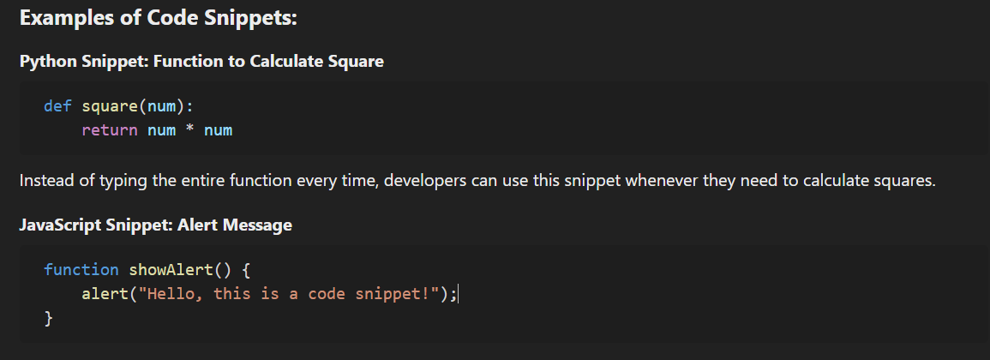
This snippet quickly creates an alert popup in a web page.

Challenges & Solutions:
- Privacy Concerns: Some developers were concerned about data security. The company opted for the Open Core version of TabNine, which runs locally without sending code to external servers.
- Learning Curve: Initially, some developers found it difficult to trust AI suggestions. A short training session was conducted to demonstrate best practices for maximizing TabNine’s effectiveness.
- Customization Needs: Developers needed personalized code suggestions. By training TabNine on the company’s existing codebase, the tool provided more relevant and consistent recommendations.
Results & Impact:
- 30% Increase in Coding Speed: Developers completed tasks faster due to quick access to accurate code snippets.
- 40% Reduction in Syntax Errors: Fewer bugs related to syntax, reducing debugging time.
- Improved Developer Productivity: With less time spent on repetitive code, developers focused on higher-level problem-solving.
- Enhanced Collaboration: Standardized auto-completions improved code consistency across teams.
Uses:
Tabnine is an AI-powered code completion tool designed to help developers write code faster and more efficiently. Here are some key uses of Tabnine:
🔹Code Completion & Autocompletion
- Suggests entire lines or blocks of code based on context.
- Provides accurate predictions, reducing typing effort.
🔹 Supports Multiple Languages
- Works with Python, Java, C++, JavaScript, and many other programming languages.
🔹 AI-Powered Suggestions
- Learns from your coding patterns and improves over time.
- Can generate function implementations based on comments or partial code.
🔹 Boosts Productivity
- Helps speed up coding by reducing syntax errors and unnecessary typing.
- Ideal for repetitive coding tasks.
🔹 Integrates with Popular IDEs
- Works with VS Code, JetBrains (PyCharm, IntelliJ IDEA), and other editors.
🔹 Privacy-Focused
- Offers local AI models that do not send code to the cloud (in pro versions).
- Ensures security while working on sensitive projects. 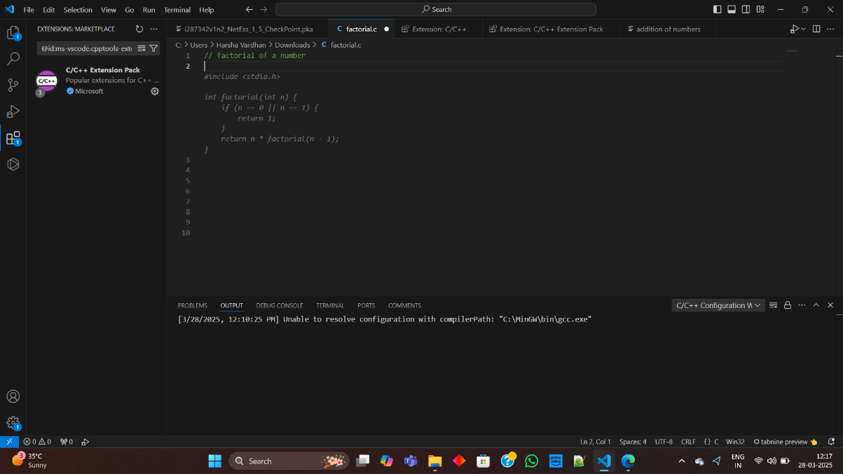
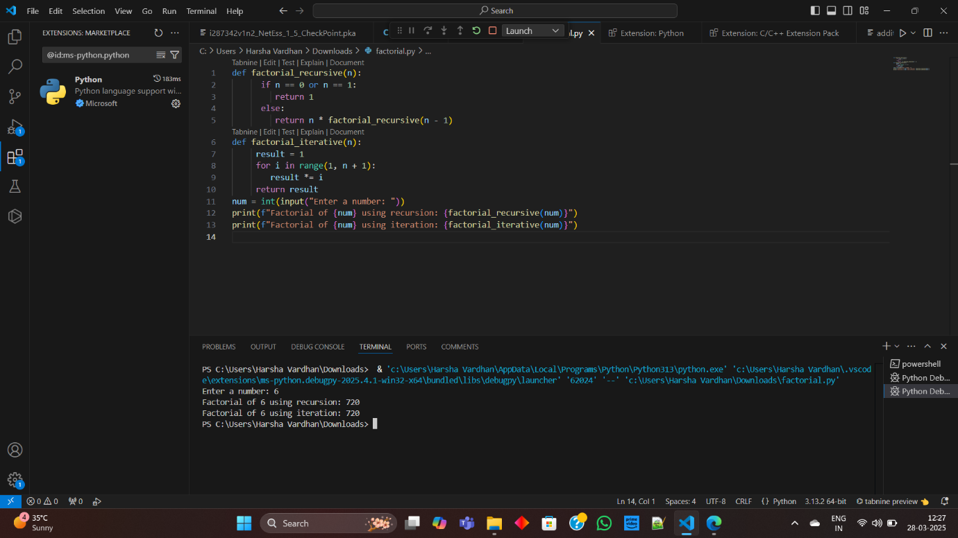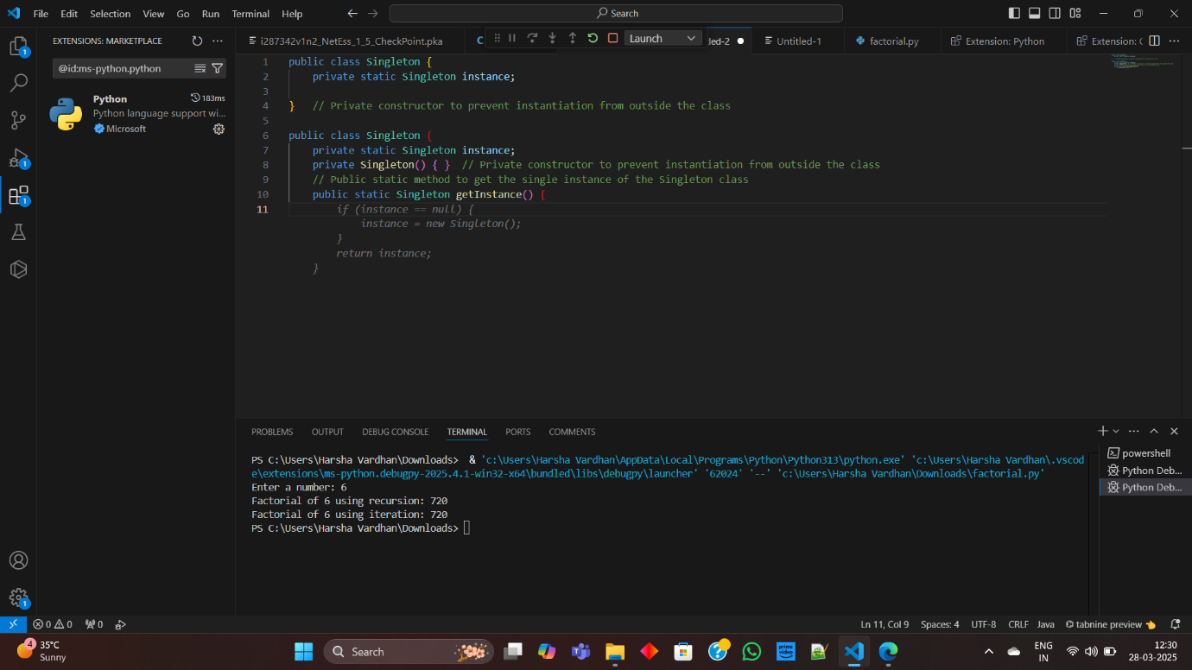
Conclusion:
TabNine (Open Core) significantly improved coding efficiency within the company, leading to faster development cycles and higher code quality. Its ability to provide real-time, context-aware code suggestions made it an invaluable tool for the development team. By leveraging AI-powered assistance while ensuring data privacy, the company successfully optimized its software development process.

